Mount Tabor Center
Totus Tuus Team Training Reservation

Mount Tabor Center
522 Second Street
Menasha, WI 54952
920-722-8918

Sunday, May 28, 2023 – Thursday, June 8, 2023
Cost: $325 per person + $325 per team
(includes overnight accommodations, all meals, materials and training)

Mount Tabor Center
Attn: Totus Tuus Coordinator
522 Second Street
Menasha, WI 54952

Please complete this form and submit with deposit of $500 to:

(Arch)Diocese of ________

Contact: __ Title:

E-mail: ______________ Phone:

Number of teachers: x $325=

Coordinator or priest: ______ x $325=

Number of teams: x $325=
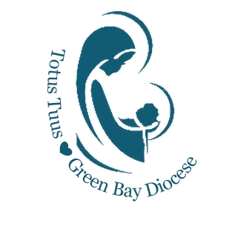

Total Cost:

Deposit: -$500 (due with this form)

Balance Due: ______

522 Second Street, Menasha, WI 54952 920-722-8918 www.totustuusgreeenbay.org

